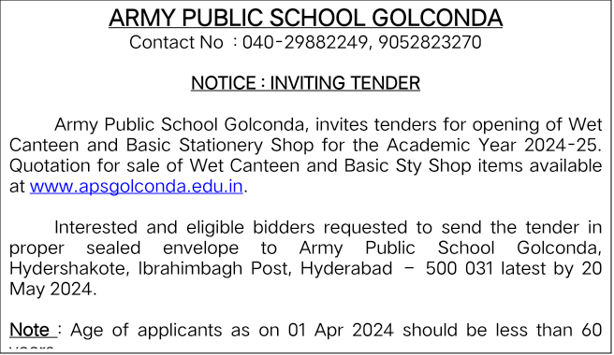

**ARMY PUBLIC SCHOOL GOLCONDA**

**QUOTATION FOR BASIC STATIONERY**

| [S.NO](http://s.no) | Description | Quantity | Rate |
| --- | --- | --- | --- |
| 1 | Gel pens | Each |  |
| 2 | Ball pens | Each |  |
| 3 | Natraj pencil | Each |  |
| 4 | Camlin pencil | Each |  |
| 5 | Apsara /Domes pencil | Each (01 paper) |  |
| 6 | A4 paper | Each (01 paper) |  |
| 7 | F/S paper | Each (01 paper) |  |
| 8 | A3 paper | Each (01 paper) |  |
| 9 | Ruled paper Legal size | Each (01 paper) |  |
| 10 | Photocopy of A4 Paper | Each |  |
| 11 | Photocopy of F/S paper | Each |  |
| 12 | Photocopy of A3 paper | Each |  |
| 13 | Maps | Each |  |
| 14 | Scissor medium | Each |  |
| 15 | Chart paper | Each |  |
| 16 | Sparkle Sheets | Each |  |
| 17 | Sparkle Stickers | Per Sheet |  |
| 18 | Ivory  chart paper | Each |  |
| 19 | Handmade sheet | Each |  |
| 20 | Fevicol tube | Each |  |
| 21 | Fevi-stick | Each |  |
| 22 | Colour tape | Each |  |
| 23 | Paper pin | Per Packet |  |
| 24 | Stapler small | Each |  |
| 25 | Stapler pin small | Per Packet |  |
| 26 | Drawing pin | Per Packet |  |
| 27 | Sketch pen small | Per Packet |  |
| 28 | Sketch pen big | Per Packet |  |
| 29 | Steel scale | Each |  |
| 30 | Plastic scale small | Each |  |
| 31 | Plastic scale big | Each |  |
| 32 | Stick flag | Per Packet |  |
| 33 | Gum bottle | Each |  |
| 34 | Button file | Each |  |

**ARMY PUBLIC SCHOOL GOLCONDA**

**QUOTATION FOR WET CANTEEN**

| [S.N](http://s.no)o | Description | Quantity | Rate |
| --- | --- | --- | --- |
| 1 | Tea-80ml | Each |  |
| 2 | Samosa | Each |  |
| 3 | Gooday Biscuit (small) | Pkt |  |
| 4 | Krackjack Biscuit (small) | Pkt |  |
| 5 | Munch chocolate | Each |  |
| 6 | Dairy Milk | Each |  |
| 7 | Veg Puff | Each |  |
| 8 | Dill Kush | Each |  |
| 9 | Idly-3 noses with chutney | Plate |  |
| 10 | Vada – 2 noses with chutney | Plate |  |
| 11 | Vegetable Biryani with Raita | Plate |  |
| 12 | Tomato Rice with Raita | Plate |  |
| 13 | Juice (Realme tetra packs) | Each |  |
| 14 | Ice creams | Each |  |